EXPERIMENT-7:
Aim: To develop an online Beauty Parlour Appointment Booking System that enables customers to book salon services, select stylists, schedule appointments, make online payments, and manage reservations efficiently through a responsive web application.
Code:
<!DOCTYPE html>
<html lang="en">
<head>
<meta charset="UTF-8">
<meta name="viewport" content="width=device-width, initial-scale=1.0">
<title>Beauty Parlour Appointment Booking System</title>

<link href="https://cdn.jsdelivr.net/npm/bootstrap@5.3.3/dist/css/bootstrap.min.css" rel="stylesheet">

<style>
body{
background:#f8f9fa;
font-family:Arial, sans-serif;
}
.hero{
background:linear-gradient(to right,#ff69b4,#ffb6c1);
color:white;
text-align:center;
padding:70px 20px;
}
.section{
display:none;
padding:20px;
}
.active{
display:block;
}
.card img{
height:220px;
object-fit:cover;
}
.footer{
background:#222;
color:white;
text-align:center;
padding:15px;
margin-top:20px;
}
</style>
</head>
<body>

<!-- Navigation -->
<nav class="navbar navbar-expand-lg navbar-dark bg-dark">
<div class="container">
<a class="navbar-brand" href="#">Beauty Parlour</a>

<div>
<button class="btn btn-outline-light btn-sm m-1" onclick="showSection('home')">Home</button>
<button class="btn btn-outline-light btn-sm m-1" onclick="showSection('services')">Services</button>
<button class="btn btn-outline-light btn-sm m-1" onclick="showSection('booking')">Book</button>
<button class="btn btn-outline-light btn-sm m-1" onclick="showSection('appointments')">My Appointments</button>
<button class="btn btn-outline-light btn-sm m-1" onclick="showSection('login')">Login</button>
<button class="btn btn-warning btn-sm m-1" onclick="showSection('admin')">Admin</button>
</div>

</div>
</nav>

<!-- Home -->
<div id="home" class="section active">
<div class="hero">
<h1>Beauty Parlour Appointment Booking</h1>
<p>Book Your Favourite Beauty Services Online</p>
<button class="btn btn-light" onclick="showSection('booking')">
Book Appointment
</button>
</div>
</div>

<!-- Services -->
<div id="services" class="section container">
<h2 class="mb-4">Our Services</h2>

<div class="row">

<div class="col-md-4">
<div class="card">
<img src="https://images.unsplash.com/photo-1522337360788-8b13dee7a37e">
<div class="card-body">
<h5>Hair Styling</h5>
<p>Professional hair styling services.</p>
</div>
</div>
</div>

<div class="col-md-4">
<div class="card">
<img src="https://images.unsplash.com/photo-1487412720507-e7ab37603c6f">
<div class="card-body">
<h5>Facial Treatment</h5>
<p>Skin care and facial treatments.</p>
</div>
</div>
</div>

<div class="col-md-4">
<div class="card">
<img src="https://images.unsplash.com/photo-1515377905703-c4788e51af15">
<div class="card-body">
<h5>Bridal Makeup</h5>
<p>Special makeup packages.</p>
</div>
</div>
</div>

</div>
</div>

<!-- Booking -->
<div id="booking" class="section container">
<h2>Book Appointment</h2>

<form>
<input type="text" class="form-control mb-3" placeholder="Customer Name">

<select class="form-control mb-3">
<option>Select Service</option>
<option>Hair Styling</option>
<option>Facial Treatment</option>
<option>Bridal Makeup</option>
<option>Manicure</option>
</select>

<select class="form-control mb-3">
<option>Select Stylist</option>
<option>Priya</option>
<option>Divya</option>
<option>Anjali</option>
</select>

<input type="date" class="form-control mb-3">

<input type="time" class="form-control mb-3">

<button type="button" class="btn btn-success"
onclick="alert('Appointment Booked Successfully!')">
Book Appointment
</button>
</form>

</div>

<!-- My Appointments -->
<div id="appointments" class="section container">

<h2>My Appointments</h2>

<table class="table table-bordered">
<tr>
<th>ID</th>
<th>Service</th>
<th>Date</th>
<th>Status</th>
</tr>

<tr>
<td>101</td>
<td>Hair Styling</td>
<td>10-08-2026</td>
<td>Confirmed</td>
</tr>

<tr>
<td>102</td>
<td>Facial</td>
<td>15-08-2026</td>
<td>Pending</td>
</tr>

</table>

</div>

<!-- Login -->
<div id="login" class="section container">

<h2>Login</h2>

<input type="email"
class="form-control mb-3"
placeholder="Email">

<input type="password"
class="form-control mb-3"
placeholder="Password">

<button class="btn btn-primary">
Login
</button>

</div>

<!-- Admin -->
<div id="admin" class="section container">

<h2>Admin Dashboard</h2>

<div class="card p-3">
<ul>
<li>Manage Services</li>
<li>Manage Stylists</li>
<li>View Appointments</li>
<li>Update Reservation Status</li>
<li>Manage Customers</li>
<li>Send SMS/Notifications</li>
<li>Manage Payments</li>
<li>View Feedback</li>
</ul>
</div>

</div>

<div class="footer">
© 2026 Beauty Parlour Appointment Booking System
</div>

<script>
function showSection(id)
{
document.querySelectorAll('.section')
.forEach(section =>
section.classList.remove('active'));

document.getElementById(id)
.classList.add('active');
}
</script>

</body>
</html>

Output:
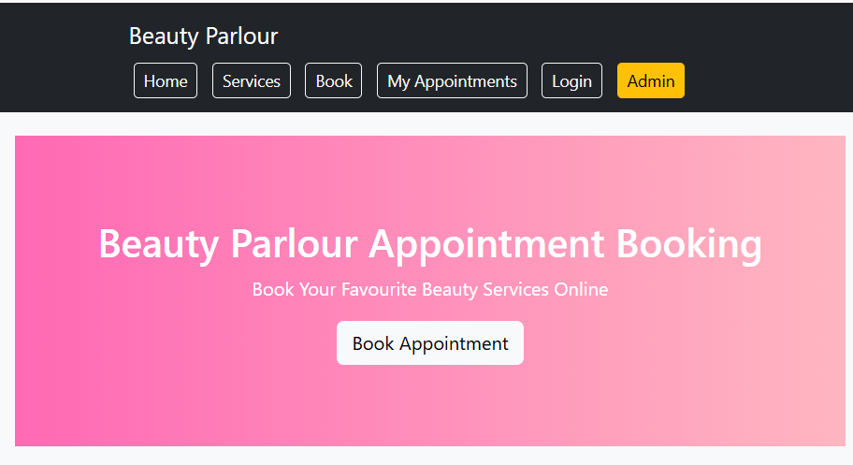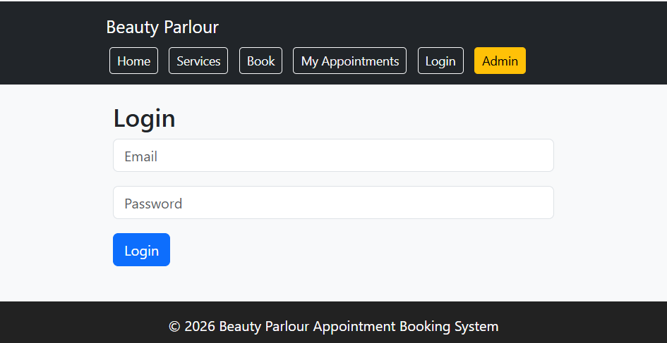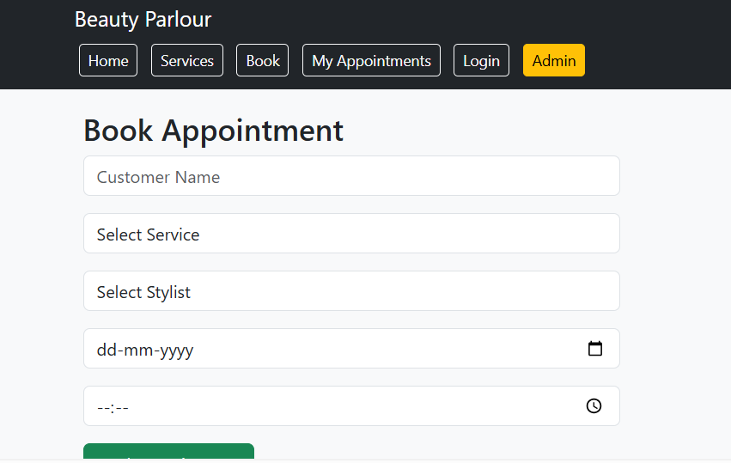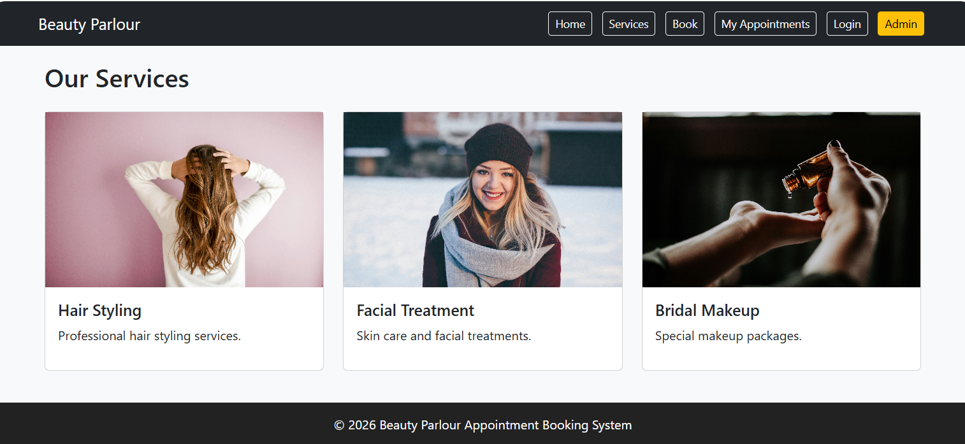

EXPERIMENT-8:
Aim: To develop an online Hospital Appointment Booking System that enables patients to search hospitals and doctors, book appointments, manage schedules, and receive appointment updates through a secure and user-friendly web application.

Code:
<!DOCTYPE html>
<html lang="en">
<head>
<meta charset="UTF-8">
<meta name="viewport" content="width=device-width, initial-scale=1.0">
<title>MedCare Hospital Appointment System</title>

<link href="https://cdn.jsdelivr.net/npm/bootstrap@5.3.3/dist/css/bootstrap.min.css" rel="stylesheet">

<style>
body{
background:#f4f6f9;
font-family:Arial,sans-serif;
}
.hero{
background:linear-gradient(to right,#007bff,#00c6ff);
color:white;
text-align:center;
padding:80px 20px;
}
.section{
display:none;
padding:20px;
}
.active{
display:block;
}
.card{
box-shadow:0 2px 10px rgba(0,0,0,0.1);
}
.footer{
background:#212529;
color:white;
text-align:center;
padding:15px;
margin-top:20px;
}
</style>
</head>
<body>

<!-- Navbar -->
<nav class="navbar navbar-expand-lg navbar-dark bg-dark">
<div class="container">
<a class="navbar-brand" href="#">MedCare Hospital</a>

<div>
<button class="btn btn-outline-light btn-sm m-1" onclick="showSection('home')">Home</button>
<button class="btn btn-outline-light btn-sm m-1" onclick="showSection('doctors')">Doctors</button>
<button class="btn btn-outline-light btn-sm m-1" onclick="showSection('booking')">Book Appointment</button>
<button class="btn btn-outline-light btn-sm m-1" onclick="showSection('history')">History</button>
<button class="btn btn-outline-light btn-sm m-1" onclick="showSection('login')">Login</button>
<button class="btn btn-warning btn-sm m-1" onclick="showSection('admin')">Admin</button>
</div>
</div>
</nav>

<!-- Home -->
<div id="home" class="section active">
<div class="hero">
<h1>Hospital Appointment Booking System</h1>
<p>Book Appointments with Doctors Anytime, Anywhere</p>
<button class="btn btn-light" onclick="showSection('booking')">
Book Now
</button>
</div>
</div>

<!-- Doctors -->
<div id="doctors" class="section container">
<h2 class="mb-4">Available Doctors</h2>

<div class="row">

<div class="col-md-4">
<div class="card">
<div class="card-body">
<h4>Dr. Rajesh</h4>
<p>Cardiologist</p>
<p>Experience: 10 Years</p>
</div>
</div>
</div>

<div class="col-md-4">
<div class="card">
<div class="card-body">
<h4>Dr. Priya</h4>
<p>Dermatologist</p>
<p>Experience: 8 Years</p>
</div>
</div>
</div>

<div class="col-md-4">
<div class="card">
<div class="card-body">
<h4>Dr. Kumar</h4>
<p>Orthopedic</p>
<p>Experience: 12 Years</p>
</div>
</div>
</div>

</div>
</div>

<!-- Booking -->
<div id="booking" class="section container">
<h2>Book Appointment</h2>

<form>

<input type="text"
class="form-control mb-3"
placeholder="Patient Name">

<input type="email"
class="form-control mb-3"
placeholder="Email">

<select class="form-control mb-3">
<option>Select Doctor</option>
<option>Dr. Rajesh</option>
<option>Dr. Priya</option>
<option>Dr. Kumar</option>
</select>

<input type="date" class="form-control mb-3">

<input type="time" class="form-control mb-3">

<button type="button"
class="btn btn-success"
onclick="alert('Appointment Booked Successfully!')">
Book Appointment
</button>

</form>
</div>

<!-- History -->
<div id="history" class="section container">

<h2>Appointment History</h2>

<table class="table table-bordered">
<tr>
<th>ID</th>
<th>Doctor</th>
<th>Date</th>
<th>Status</th>
</tr>

<tr>
<td>201</td>
<td>Dr. Rajesh</td>
<td>12-08-2026</td>
<td>Confirmed</td>
</tr>

<tr>
<td>202</td>
<td>Dr. Priya</td>
<td>18-08-2026</td>
<td>Pending</td>
</tr>

</table>

</div>

<!-- Login -->
<div id="login" class="section container">

<h2>Patient Login</h2>

<input type="email"
class="form-control mb-3"
placeholder="Email">

<input type="password"
class="form-control mb-3"
placeholder="Password">

<button class="btn btn-primary">
Login
</button>

</div>

<!-- Admin -->
<div id="admin" class="section container">

<h2>Admin Dashboard</h2>

<div class="card p-3">
<ul>
<li>Manage Doctors</li>
<li>Manage Hospitals</li>
<li>Manage Appointments</li>
<li>View Appointment Statistics</li>
<li>Manage Reviews & Ratings</li>
<li>Update Doctor Schedules</li>
<li>Manage Patients</li>
<li>Generate Reports</li>
</ul>
</div>

</div>

<div class="footer">
© 2026 MedCare Hospital Appointment Booking System
</div>

<script>
function showSection(id)
{
document.querySelectorAll('.section')
.forEach(section =>
section.classList.remove('active'));

document.getElementById(id)
.classList.add('active');
}
</script>

</body>
</html>
Output:
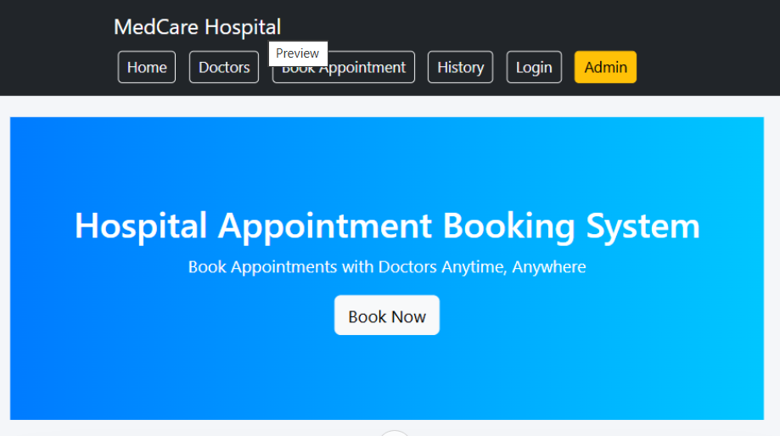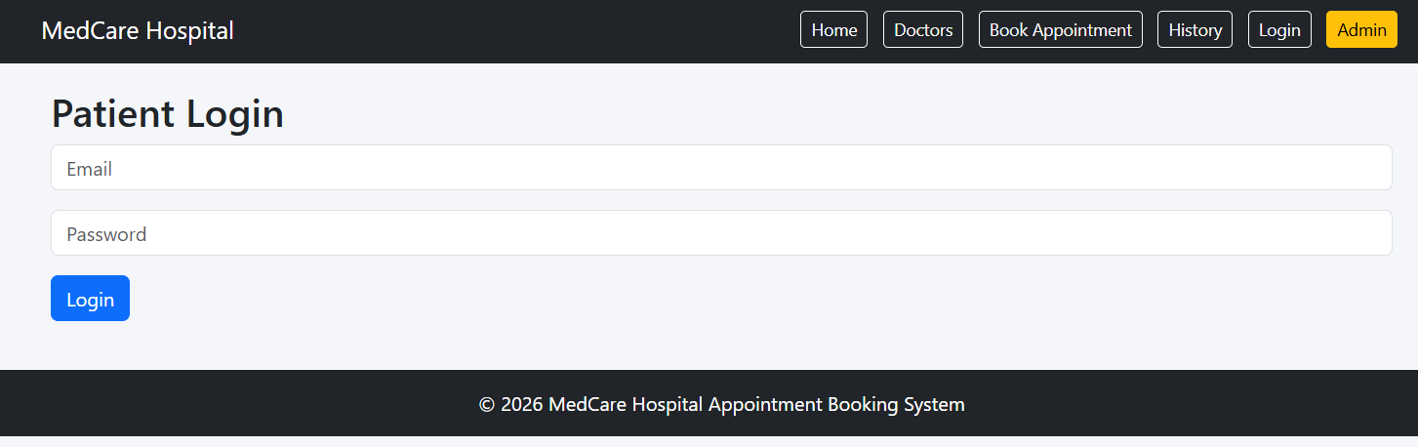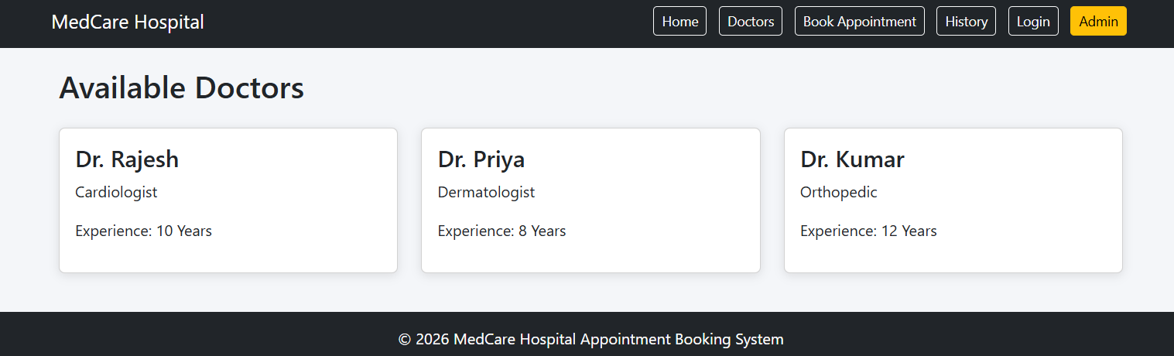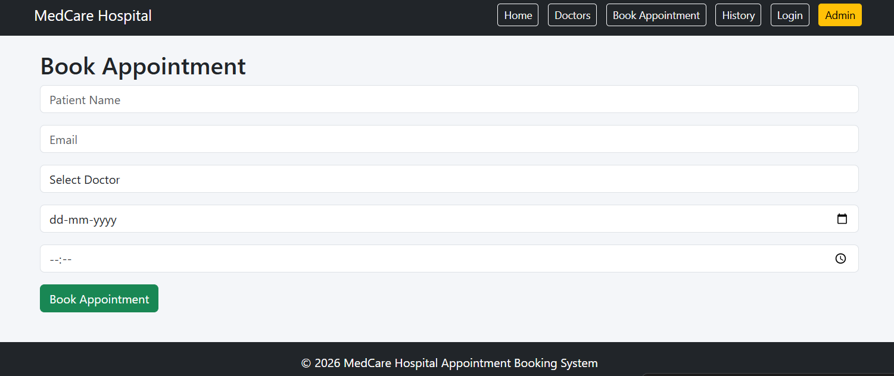

Experiment-9:
Aim: To develop an online Hospital Appointment Booking System that allows patients to search hospitals and doctors, book appointments, manage appointment schedules, and receive notifications through a secure and user-friendly web platform.

Code:
<!DOCTYPE html>
<html>
<head>
<title>Hospital Appointment Booking System</title>
<style>
body{
font-family: Arial, sans-serif;
background:#f4f6f9;
margin:0;
}
header{
background:#007bff;
color:white;
padding:15px;
text-align:center;
}
nav{
background:#333;
padding:10px;
text-align:center;
}
nav a{
color:white;
text-decoration:none;
margin:15px;
}
.container{
padding:20px;
}
.card{
background:white;
padding:15px;
margin:10px 0;
border-radius:5px;
box-shadow:0 0 5px gray;
}
input,select{
width:100%;
padding:10px;
margin:8px 0;
}
button{
background:#28a745;
color:white;
border:none;
padding:10px 20px;
cursor:pointer;
}
footer{
background:#222;
color:white;
text-align:center;
padding:10px;
margin-top:20px;
}
</style>
</head>
<body>

<header>
<h1>MedCare Hospital Appointment Booking System</h1>
</header>

<nav>
<a href="#">Home</a>
<a href="#">Doctors</a>
<a href="#">Appointments</a>
<a href="#">Login</a>
</nav>

<div class="container">

<div class="card">
<h2>Patient Registration</h2>
<input type="text" placeholder="Patient Name">
<input type="email" placeholder="Email">
<input type="password" placeholder="Password">
<button>Register</button>
</div>

<div class="card">
<h2>Book Appointment</h2>

<select>
<option>Select Doctor</option>
<option>Dr. Rajesh - Cardiologist</option>
<option>Dr. Priya - Dermatologist</option>
<option>Dr. Kumar - Orthopedic</option>
</select>

<input type="date">
<input type="time">

<button onclick="bookAppointment()">
Book Appointment
</button>
</div>

<div class="card">
<h2>Appointment Status</h2>

<table border="1" width="100%">
<tr>
<th>Appointment ID</th>
<th>Doctor</th>
<th>Date</th>
<th>Status</th>
</tr>

<tr>
<td>1001</td>
<td>Dr. Rajesh</td>
<td>10-08-2026</td>
<td>Confirmed</td>
</tr>
</table>
</div>

<div class="card">
<h2>Admin Dashboard</h2>
<ul>
<li>Manage Doctors</li>
<li>Manage Hospitals</li>
<li>Manage Appointments</li>
<li>View Statistics</li>
<li>Generate Reports</li>
</ul>
</div>

</div>

<footer>
© 2026 Hospital Appointment Booking System
</footer>

<script>
function bookAppointment()
{
alert("Appointment Booked Successfully!");
}
</script>

</body>
</html>

Output:
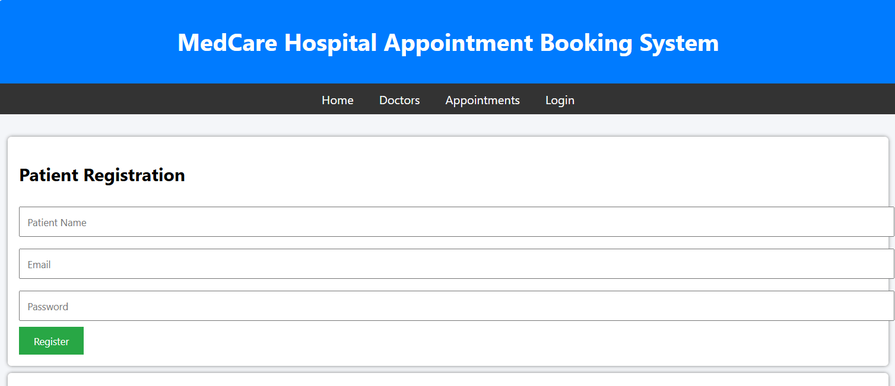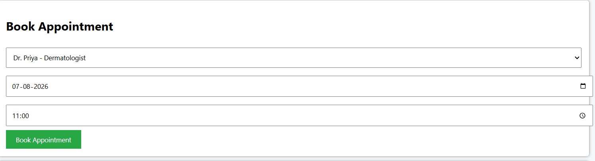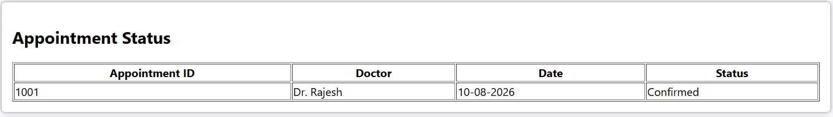

Experiment-10:
Aim: To develop an online fashion e-commerce platform that enables customers to browse, search, and purchase fashion products, manage orders, and make secure online payments through a user-friendly web application.

Code:
<!DOCTYPE html>
<html lang="en">
<head>
<meta charset="UTF-8">
<meta name="viewport" content="width=device-width, initial-scale=1.0">
<title>StyleHub Fashion E-Commerce</title>

<link href="https://cdn.jsdelivr.net/npm/bootstrap@5.3.3/dist/css/bootstrap.min.css" rel="stylesheet">

<style>
body{
font-family: Arial, sans-serif;
background:#f8f9fa;
}

.hero{
background: linear-gradient(135deg,#6f42c1,#e83e8c);
color:white;
text-align:center;
padding:80px 20px;
}

.section{
display:none;
padding:20px;
}

.active{
display:block;
}

.card{
margin-bottom:20px;
}

.card img{
height:250px;
object-fit:cover;
}

.footer{
background:#212529;
color:white;
text-align:center;
padding:15px;
margin-top:20px;
}
</style>
</head>
<body>

<!-- Navbar -->
<nav class="navbar navbar-expand-lg navbar-dark bg-dark">
<div class="container">
<a class="navbar-brand" href="#">StyleHub</a>

<div>
<button class="btn btn-outline-light btn-sm m-1" onclick="showSection('home')">Home</button>
<button class="btn btn-outline-light btn-sm m-1" onclick="showSection('products')">Products</button>
<button class="btn btn-outline-light btn-sm m-1" onclick="showSection('cart')">Cart</button>
<button class="btn btn-outline-light btn-sm m-1" onclick="showSection('orders')">Orders</button>
<button class="btn btn-outline-light btn-sm m-1" onclick="showSection('login')">Login</button>
<button class="btn btn-warning btn-sm m-1" onclick="showSection('admin')">Admin</button>
</div>
</div>
</nav>

<!-- Home -->
<div id="home" class="section active">
<div class="hero">
<h1>StyleHub Fashion Store</h1>
<p>Discover the Latest Fashion Trends</p>
<button class="btn btn-light" onclick="showSection('products')">
Shop Now
</button>
</div>
</div>

<!-- Products -->
<div id="products" class="section container">

<h2 class="mb-4">Fashion Collection</h2>

<div class="row">

<div class="col-md-4">
<div class="card">
<img src="https://images.unsplash.com/photo-1521572163474-6864f9cf17ab" class="card-img-top">
<div class="card-body">
<h5>Men's Casual Shirt</h5>
<p>Price: ₹999</p>
<button class="btn btn-primary" onclick="addToCart('Men Casual Shirt')">
Add to Cart
</button>
</div>
</div>
</div>

<div class="col-md-4">
<div class="card">
<img src="https://images.unsplash.com/photo-1483985988355-763728e1935b" class="card-img-top">
<div class="card-body">
<h5>Women's Dress</h5>
<p>Price: ₹1499</p>
<button class="btn btn-primary" onclick="addToCart('Women Dress')">
Add to Cart
</button>
</div>
</div>
</div>

<div class="col-md-4">
<div class="card">
<img src="https://images.unsplash.com/photo-1542291026-7eec264c27ff" class="card-img-top">
<div class="card-body">
<h5>Fashion Shoes</h5>
<p>Price: ₹1999</p>
<button class="btn btn-primary" onclick="addToCart('Fashion Shoes')">
Add to Cart
</button>
</div>
</div>
</div>

</div>
</div>

<!-- Cart -->
<div id="cart" class="section container">
<h2>Shopping Cart</h2>
<ul id="cartItems" class="list-group"></ul>
</div>

<!-- Orders -->
<div id="orders" class="section container">
<h2>My Orders</h2>

<table class="table table-bordered">
<tr>
<th>Order ID</th>
<th>Product</th>
<th>Status</th>
</tr>

<tr>
<td>5001</td>
<td>Men's Casual Shirt</td>
<td>Delivered</td>
</tr>

<tr>
<td>5002</td>
<td>Fashion Shoes</td>
<td>Shipped</td>
</tr>

</table>
</div>

<!-- Login -->
<div id="login" class="section container">

<h2>User Login</h2>

<input type="email"
class="form-control mb-3"
placeholder="Email">

<input type="password"
class="form-control mb-3"
placeholder="Password">

<button class="btn btn-success">
Login
</button>

</div>

<!-- Admin -->
<div id="admin" class="section container">

<h2>Admin Dashboard</h2>

<div class="card p-3">

<ul>
<li>Manage Products</li>
<li>Add New Products</li>
<li>Update Product Prices</li>
<li>Manage Orders</li>
<li>Manage Customers</li>
<li>Sales Reports</li>
<li>Category Management</li>
<li>Inventory Management</li>
</ul>

</div>

</div>

<div class="footer">
© 2026 StyleHub Fashion E-Commerce Platform
</div>

<script>

function showSection(id)
{
document.querySelectorAll('.section')
.forEach(section =>
section.classList.remove('active'));

document.getElementById(id)
.classList.add('active');
}

function addToCart(product)
{
let item=document.createElement("li");
item.className="list-group-item";
item.innerText=product;

document.getElementById("cartItems")
.appendChild(item);

alert(product + " added to cart!");
}

</script>

</body>
</html>
Output:
